Study Guide: Rocks and the Rock Cycle Name: _________________

- What is the definition of a rock?____a mixture of rock particles, minerals, and sometimes organic matter________

- What are the three types of rock? How do they form?
  - __igneous_________: _____melting and cooling_________________________
  - __sedimentary_____: _____sediment that is compacted together___________
  - __metamorphic____: _____heat and pressure___________________________

- What are the steps/processes to make a clastic sedimentary rock? Define each step.
  - __weathering______: ___breaking of rock into pieces_________________________
  - __erosion_________: ___movement of sediment_____________________________
  - __deposition______: ____settling of sediment into layers_______________________
  - __compaction_____: ____pressing of sediment together to form rock_____________
  - __cementation____: ____natural gluing of sediment____________________________

- What are the two classifications of metamorphic rock? Describe each in a few words.
  - __foliated______: _____mineral grains are arranged in parallel layers_________
  - __nonfoliated___: _____ mineral grains are NOT arranged in parallel layers ____

- What are the two classifications of igneous rock? Describe each in a few words.
  - _intrusive_________: __formed from slowly cooling magma below Earth’s surface__
  - _extrusive_________: __formed from quickly cooling lava on Earth’s surface_______

- What are the other two classifications of sedimentary rock (clastic already has been described in question 3)? Describe each in a few words.
  - _chemical___________: __formed from solutions that evaporated_________________
  - __organic___________: ___ made from the remains of once living things___________

- What makes an igneous rock have large crystals vs. no crystals or vesicles (air bubbles)?
____intrusive igneous rocks cool slowly allowing crystals a long to form, however extrusive igneous rocks cool quickly not allowing crystals time to form or air bubbles may get trapped.___

- What is the rock cycle?___process by which rocks change into other rocks___________

SEE THE BACK TO COMPLETE THE DIAGRAM

- Fill in the chart below.
Word Bank:
Sedimentary rock
Sediment
Igneous Rock
Metamorphic Rock
Magma or Lava (molten rock)
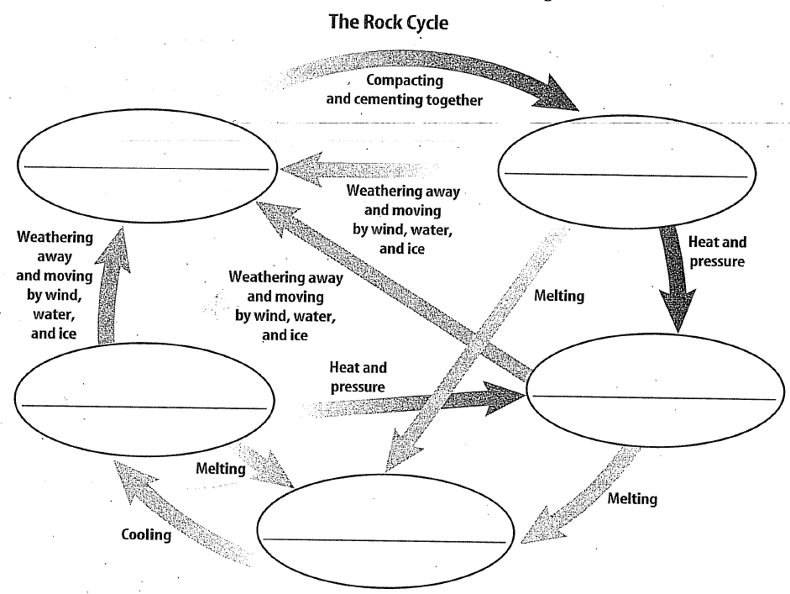
Metamorphic Rock
Magma/lava
Igneous Rock
Sediment
Sedimentary
- ALSO LOOK OVER:
  - ROCKS FLIPCHART
  - ROCKS PAMPHLET (PINK)
  - ROCK CYCLE DIAGRAM

